**1.Install Git:**

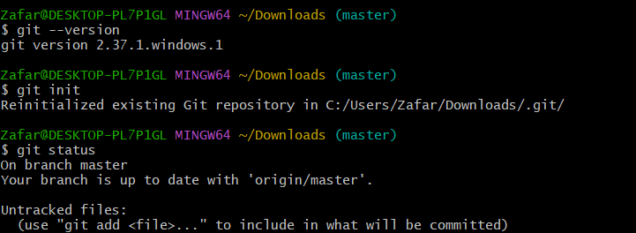

**2.Create a repo in github with README.md and .ignore file.**

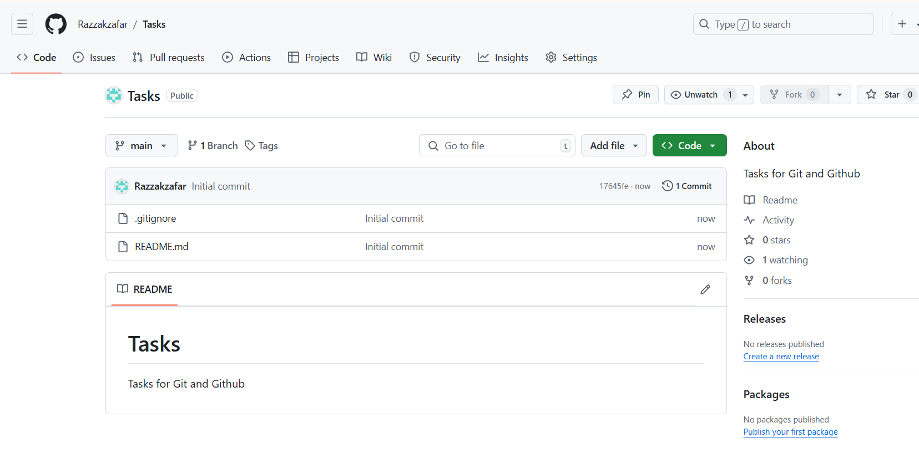

**3)Clone the created repo to local.**

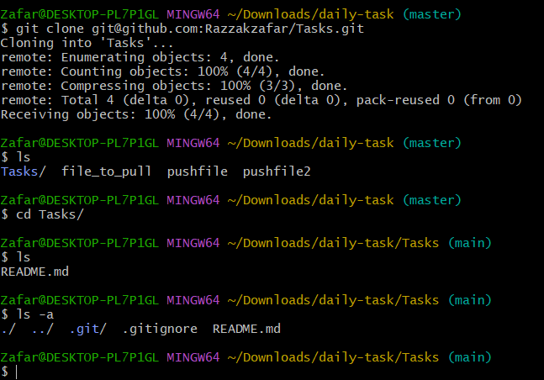

**4)Create two files in local repo.**

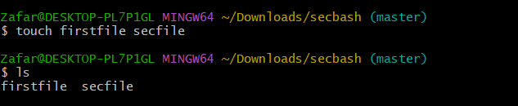

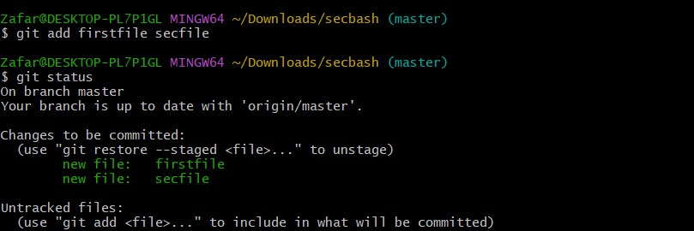

**5)Commit two files and push to central Repository.**

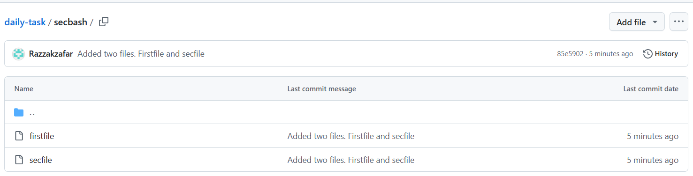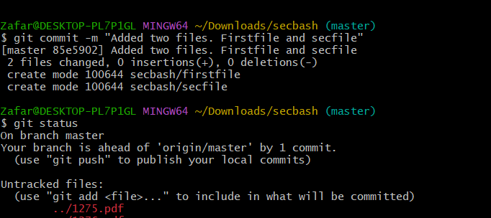

6)Create a branch in local and create a sample file and push to central.

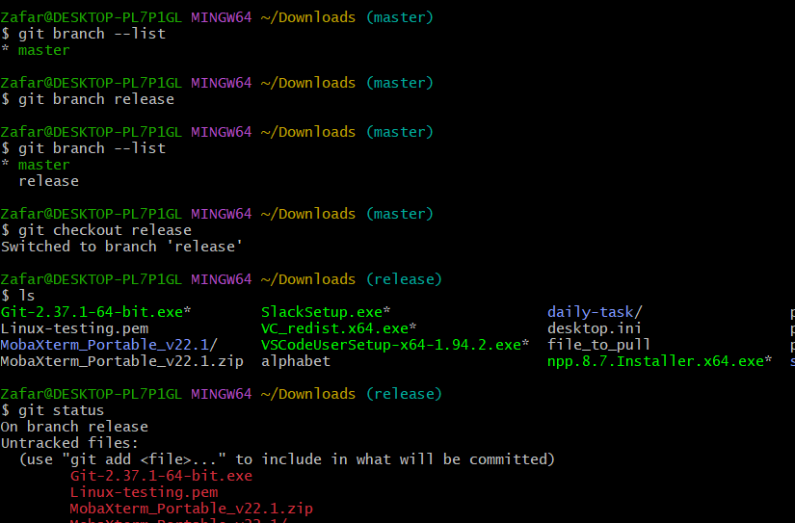

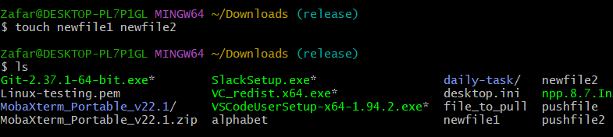

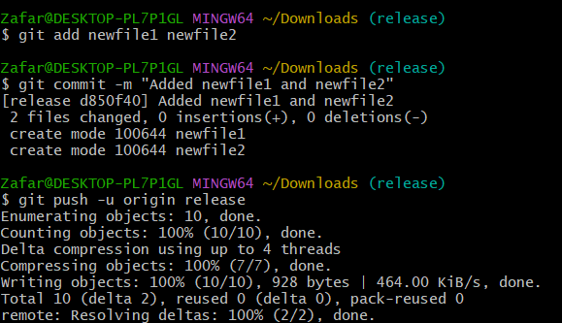

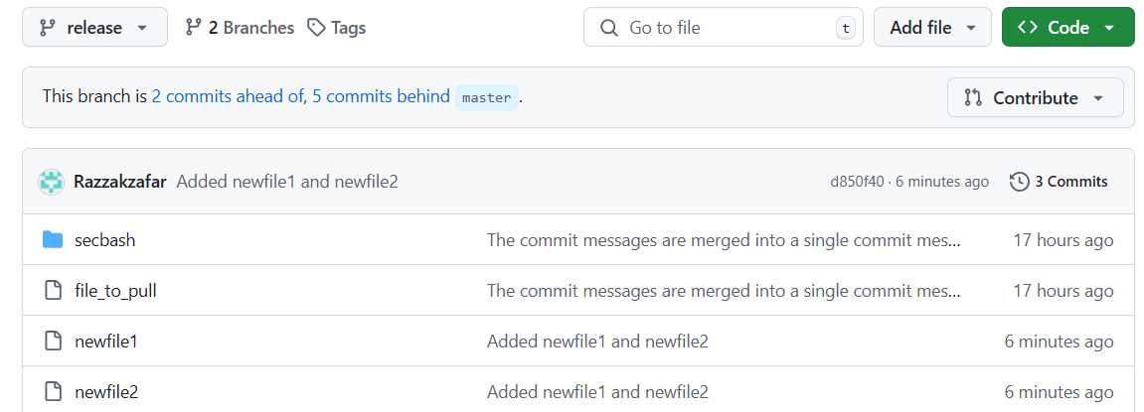

**7)Create a branch in github and clone that to local**

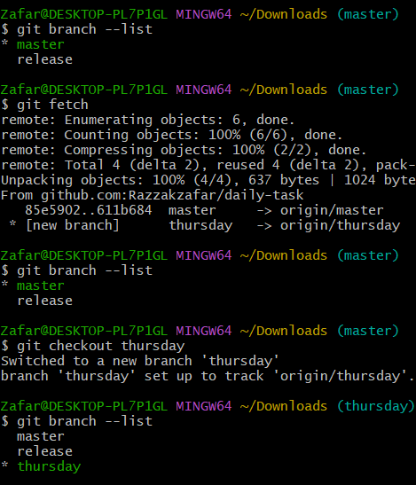

**8)Merge the created branch with master in git local.**

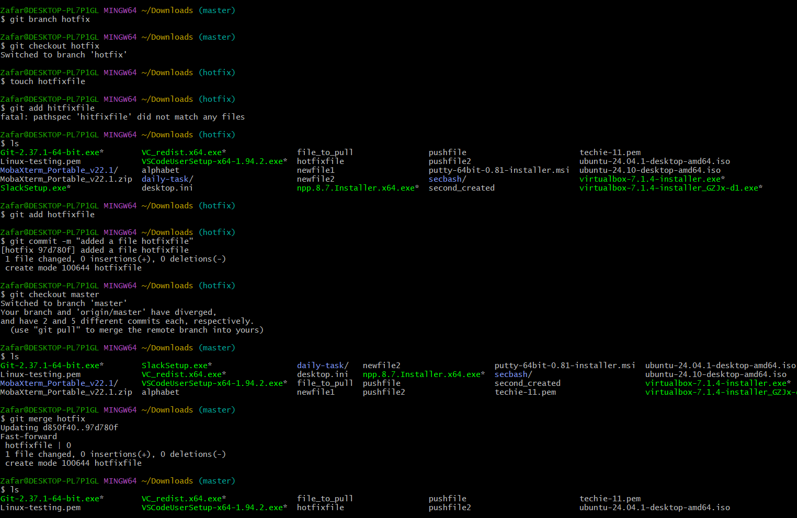

**9)Merge the created branch with master in github by sending a pull request.**

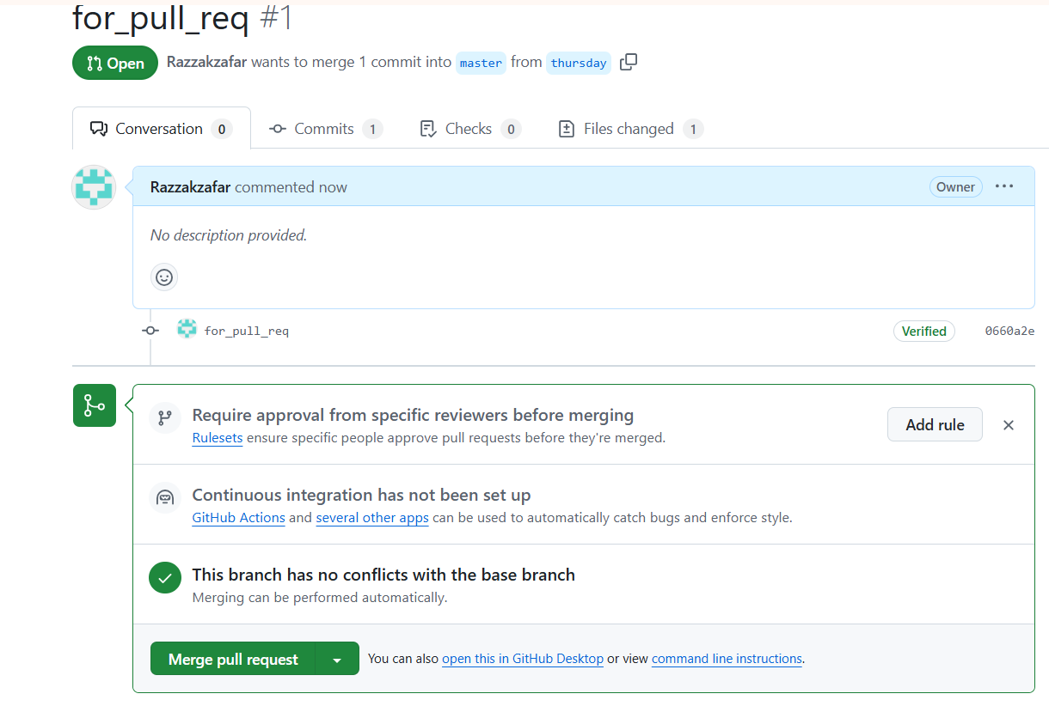

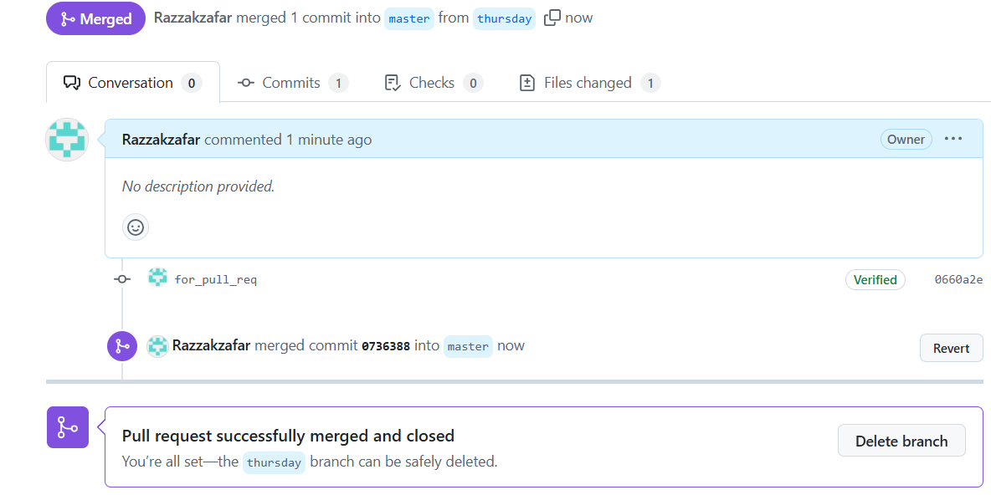

**10)create a file in local and send that to branch in github.**

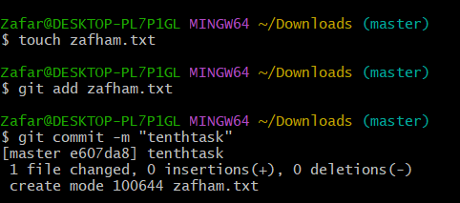

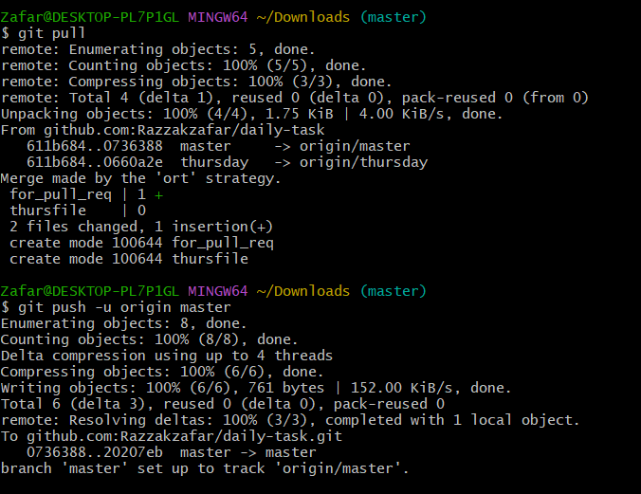

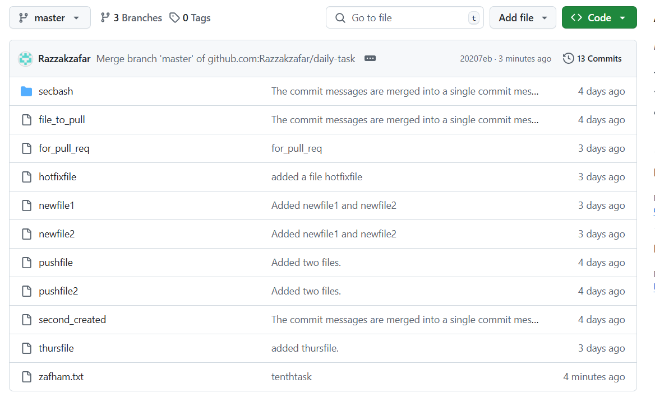**11)clone only a branch from github to local.**

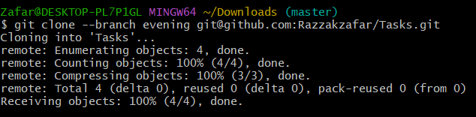

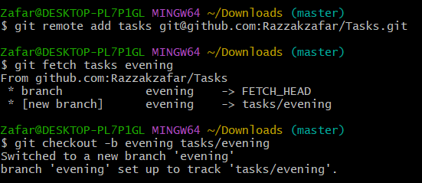

**12)create a file with all passwords and make that untrackable with git.**

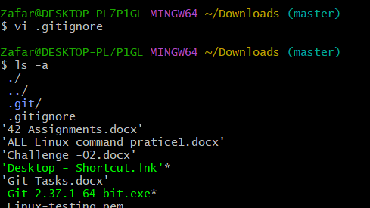

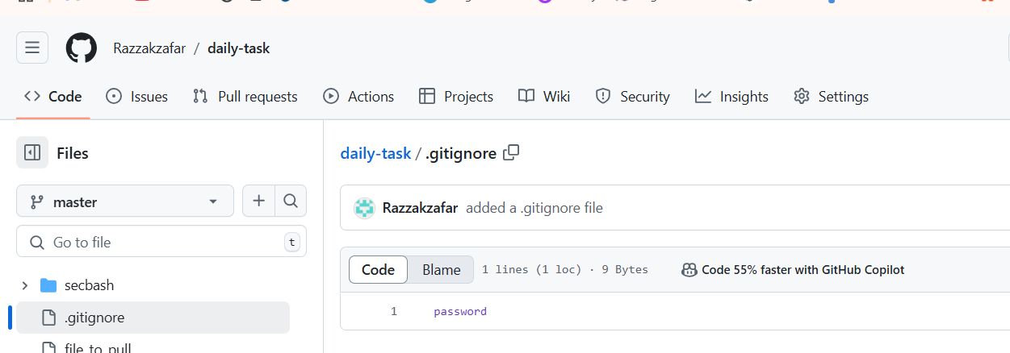

**13)make a commit and make that commit reset without savings changes.**

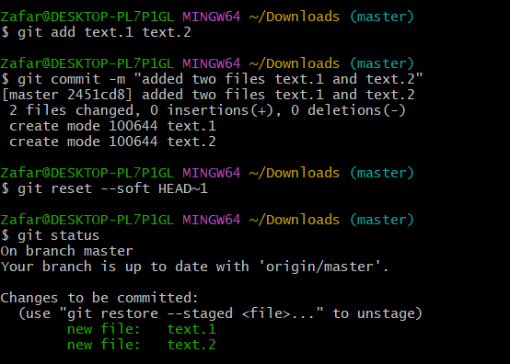

**14)Revert a commited commit to the older version.**

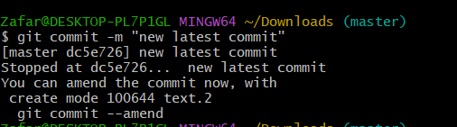

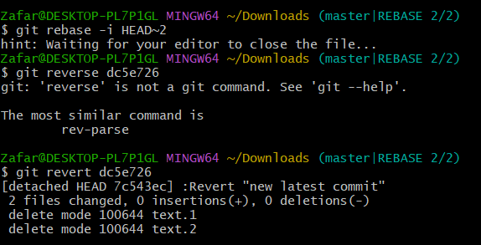

**15)push a file to stash without savings the changes and work on another file.**

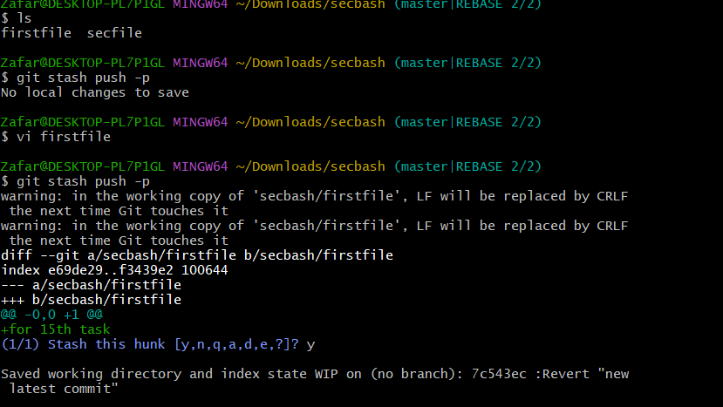

**16)undo the stash file and start working on that again.**

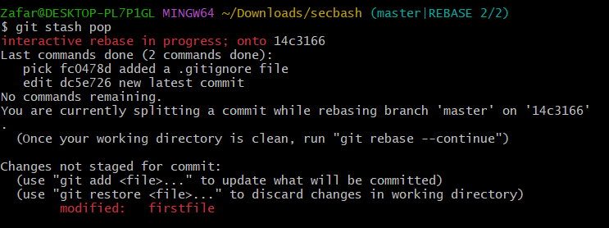

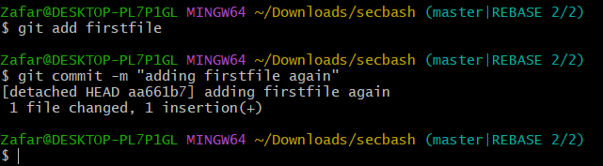

17)**generate a ssh-keygen and configure into github.**

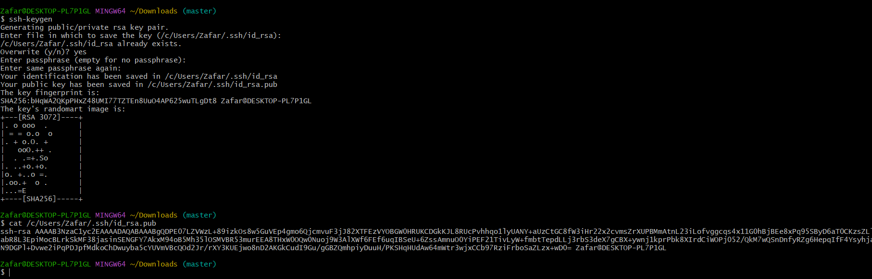

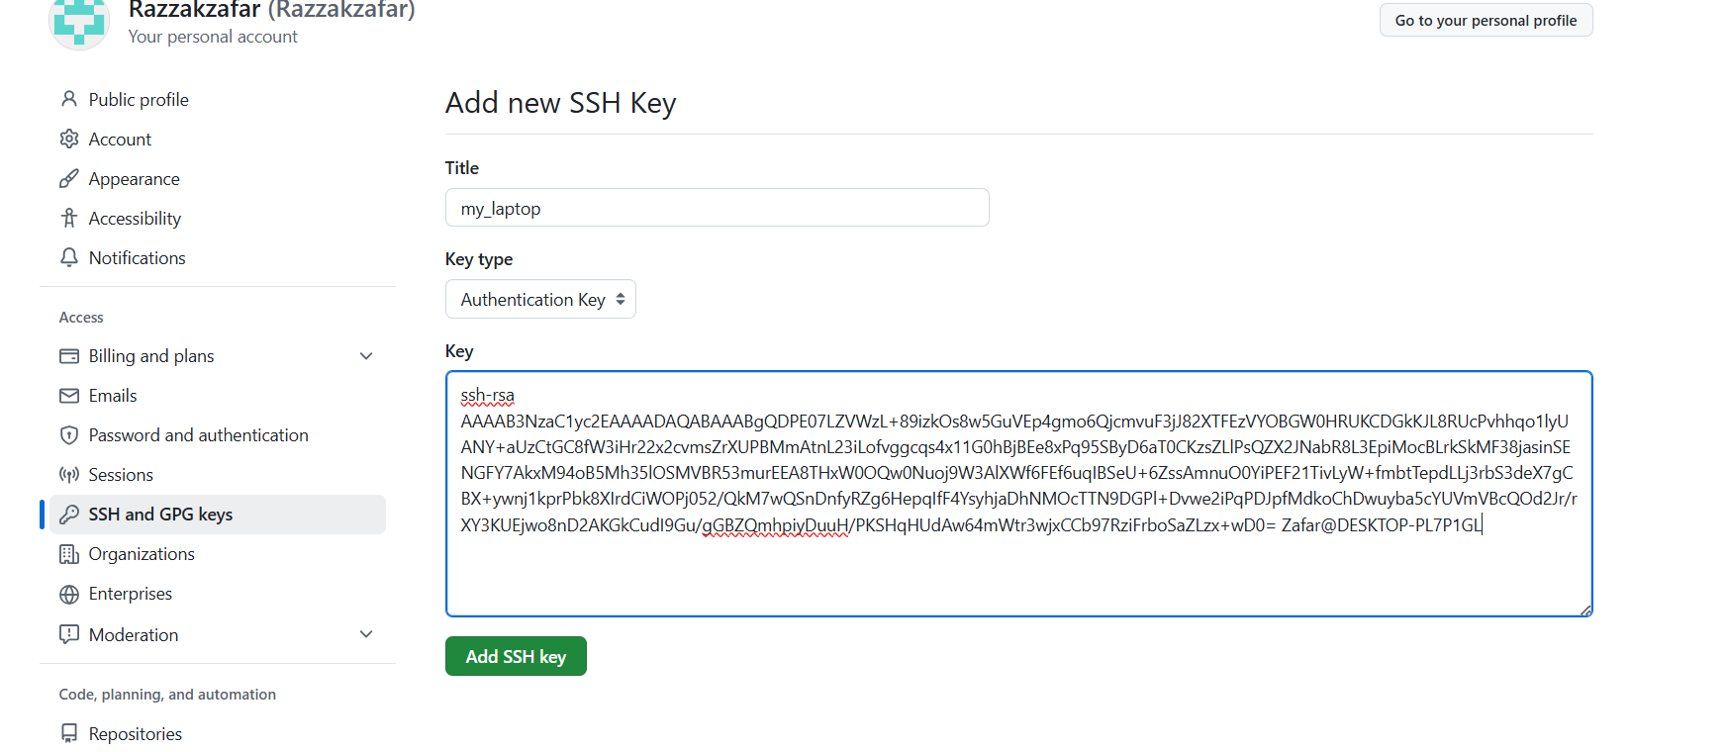

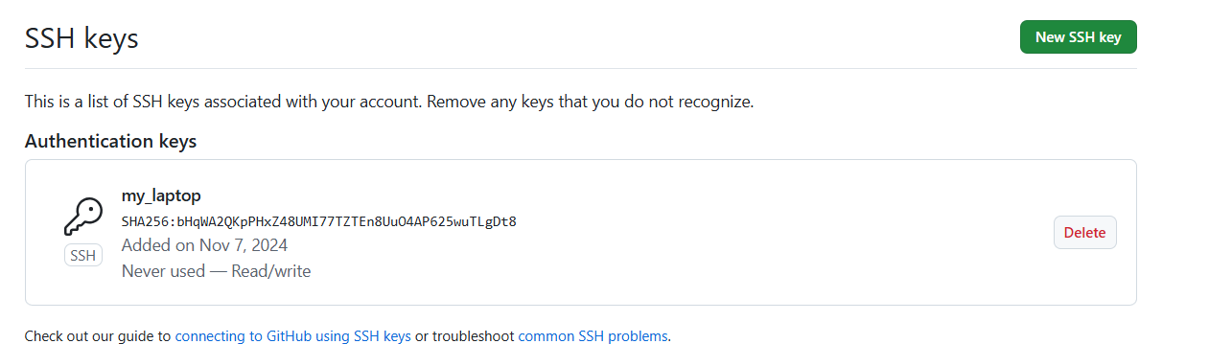**19)basic understanding of .git file.**

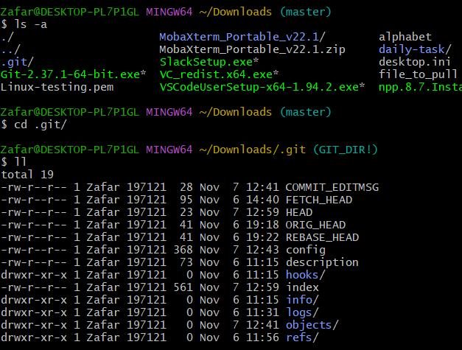

**20)Check all the logs of git.**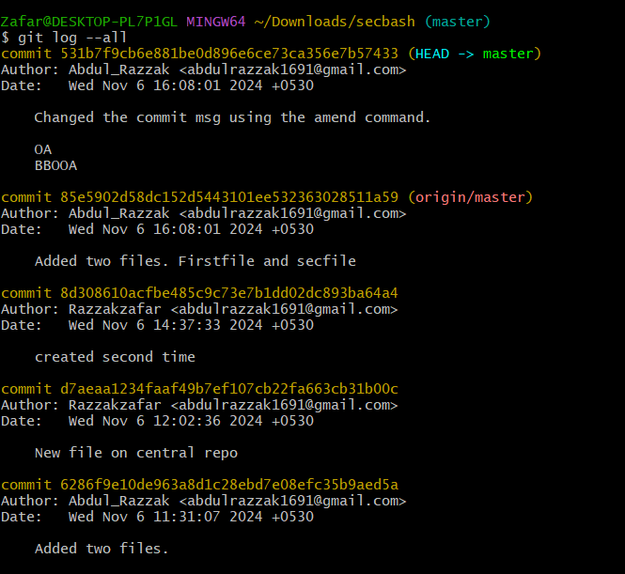

**21)Rename the commit message.**

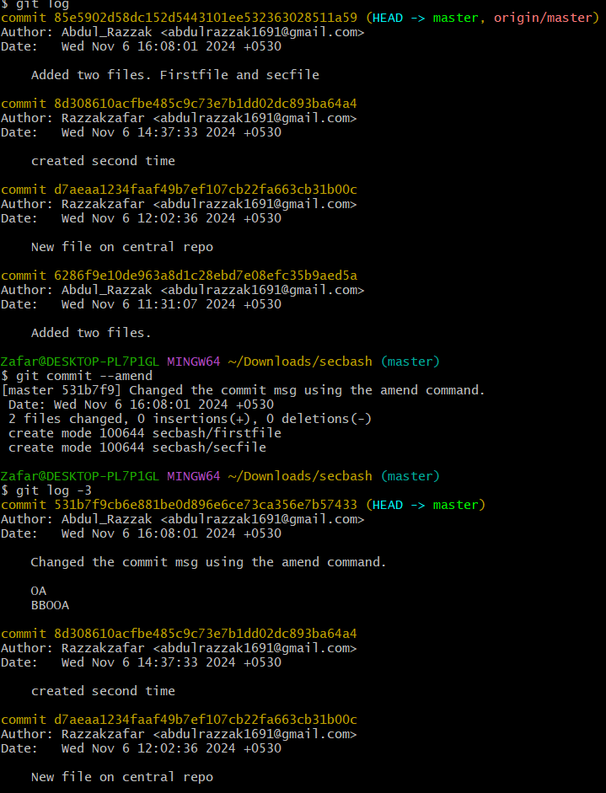

**22)Merge multiple commits into single commit.**

